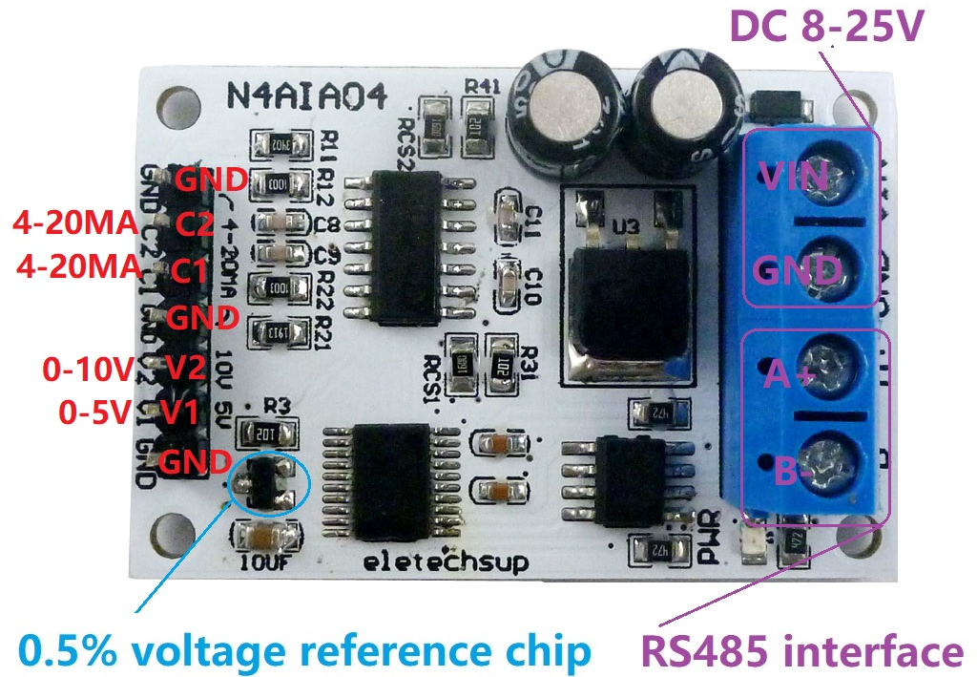**Features:**

1: Operating Voltage : DC 8-25V(DC 9V 12V 15V 24V)

2: Operating Current : 10-14MA

3: MODBUS RTU Command support 03 06 function code

4: V1(CH1) channel voltage measurement range is 0-5V, V2(CH2) channel voltage measurement range is 0-10V, C1/C2(CH3/4) channel current measurement range is 0-20MA/4-20MA

5: Voltage resolution is 0.01V, measurement accuracy is 1%; current resolution is 0.1MA, measurement accuracy is 1%; if the error is greater than 1%, it can be calibrated

6 :MODBUS commands can be made serial HyperTerminal (serial assistant) OR PLC Enter;

7 :Under the MODBUS command mode, it can support up to 247 devices in parallel

8 :Size: 45 * 30 * 15mm

9 :Weight: 10 g

Modbus RTU Command Please refer to : "N4AIA04 modbus rtu protocol"

**Wiring diagram:**

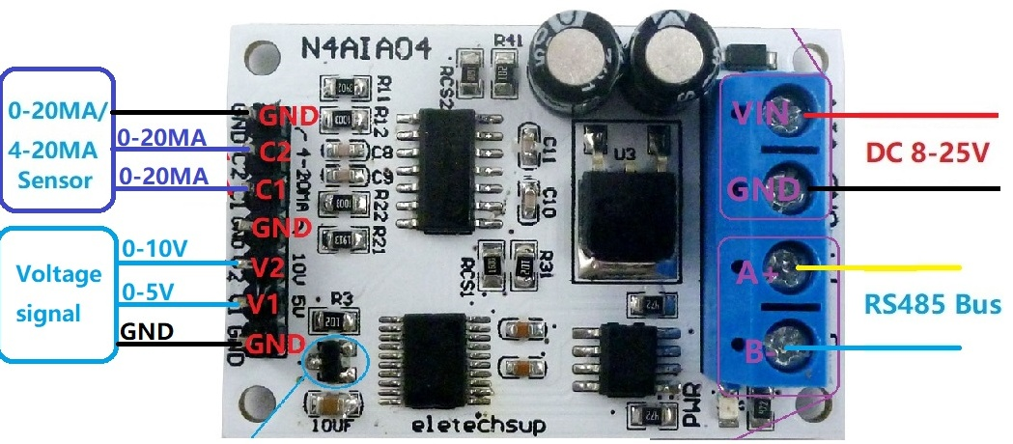

Slave ID: Different "Sliver ID" can be set by command, the maximum number is 247

Under the MODBUS command mode,the slave ID must be correct

Command Description, Please refer to " N4AIA04 modbus rtu protocol "

